**CODTECH INTERNSHIP TASK -2**

**CLOUD MONITORING AND ALERTS:-**

SET UP MONITORING FOR A CLOUDBASED APPLICATION USING AWS CLOUDWATCH, GOOGLE CLOUD MONITORING, OR AZURE MONITOR.

DELIVERABLE: CONFIGURED ALERTS AND A DASHBOARD SHOWCASING METRICS.

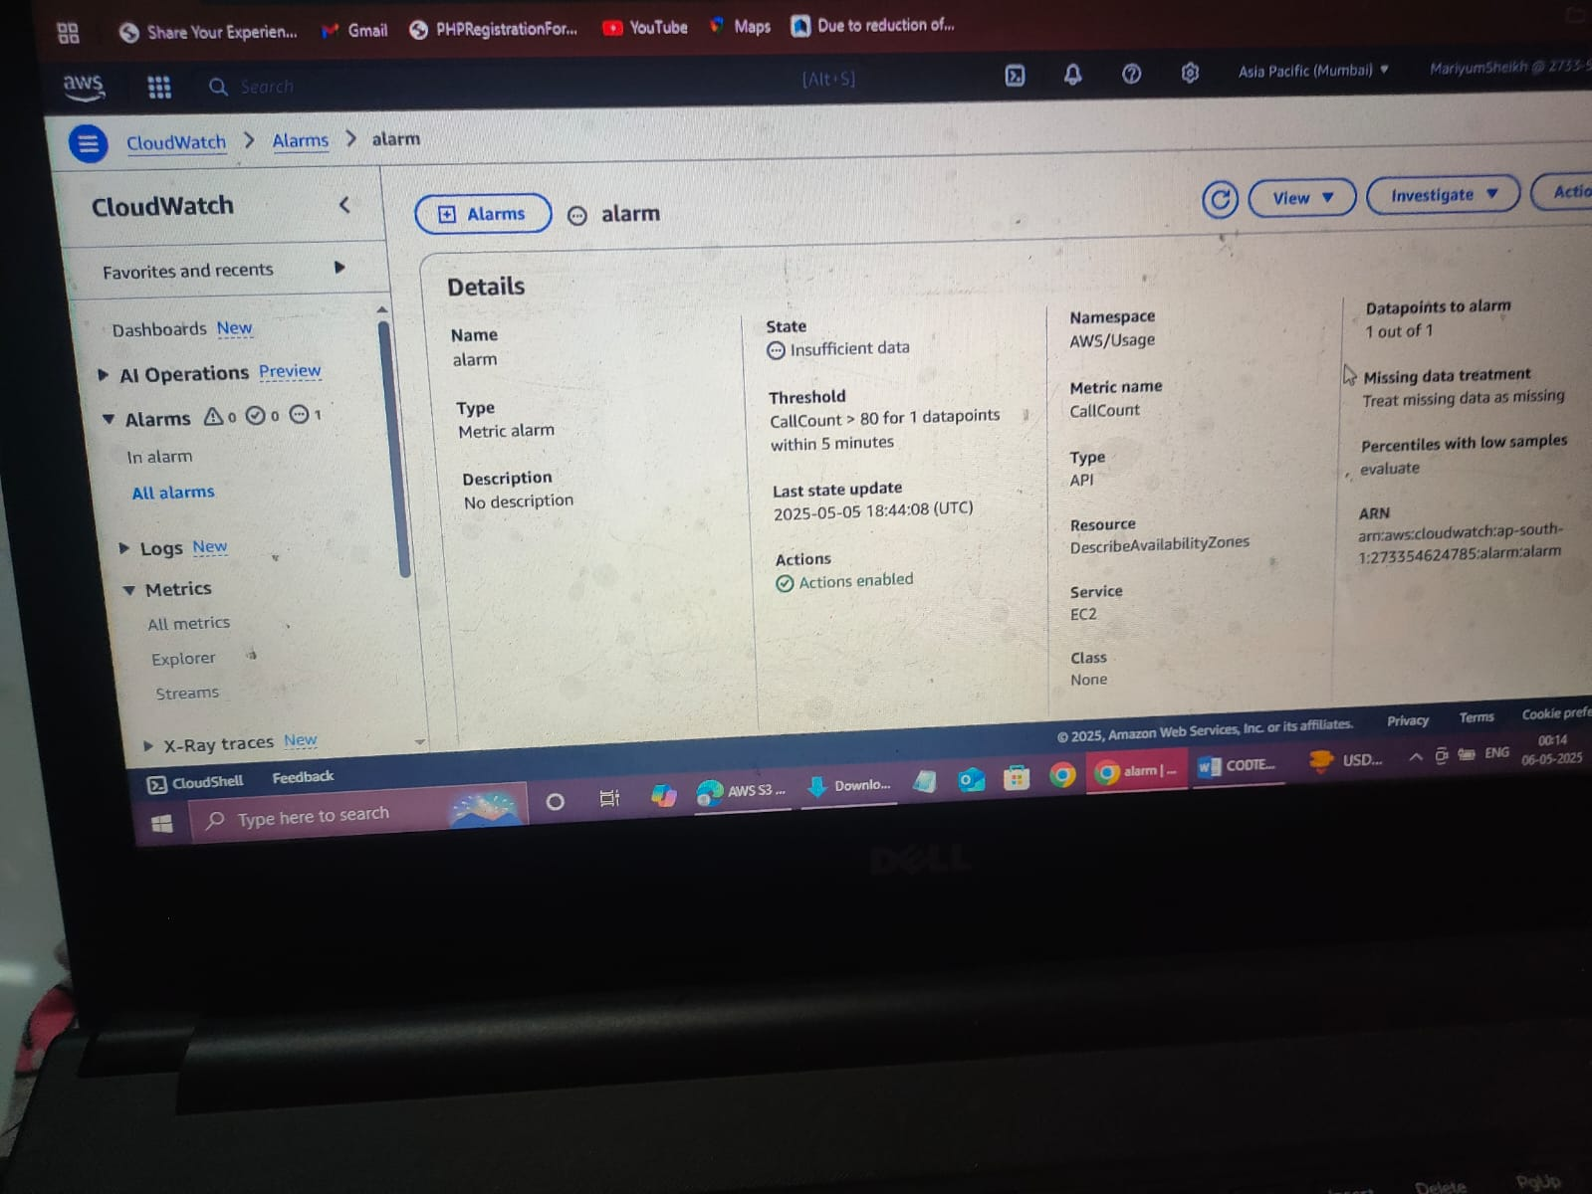

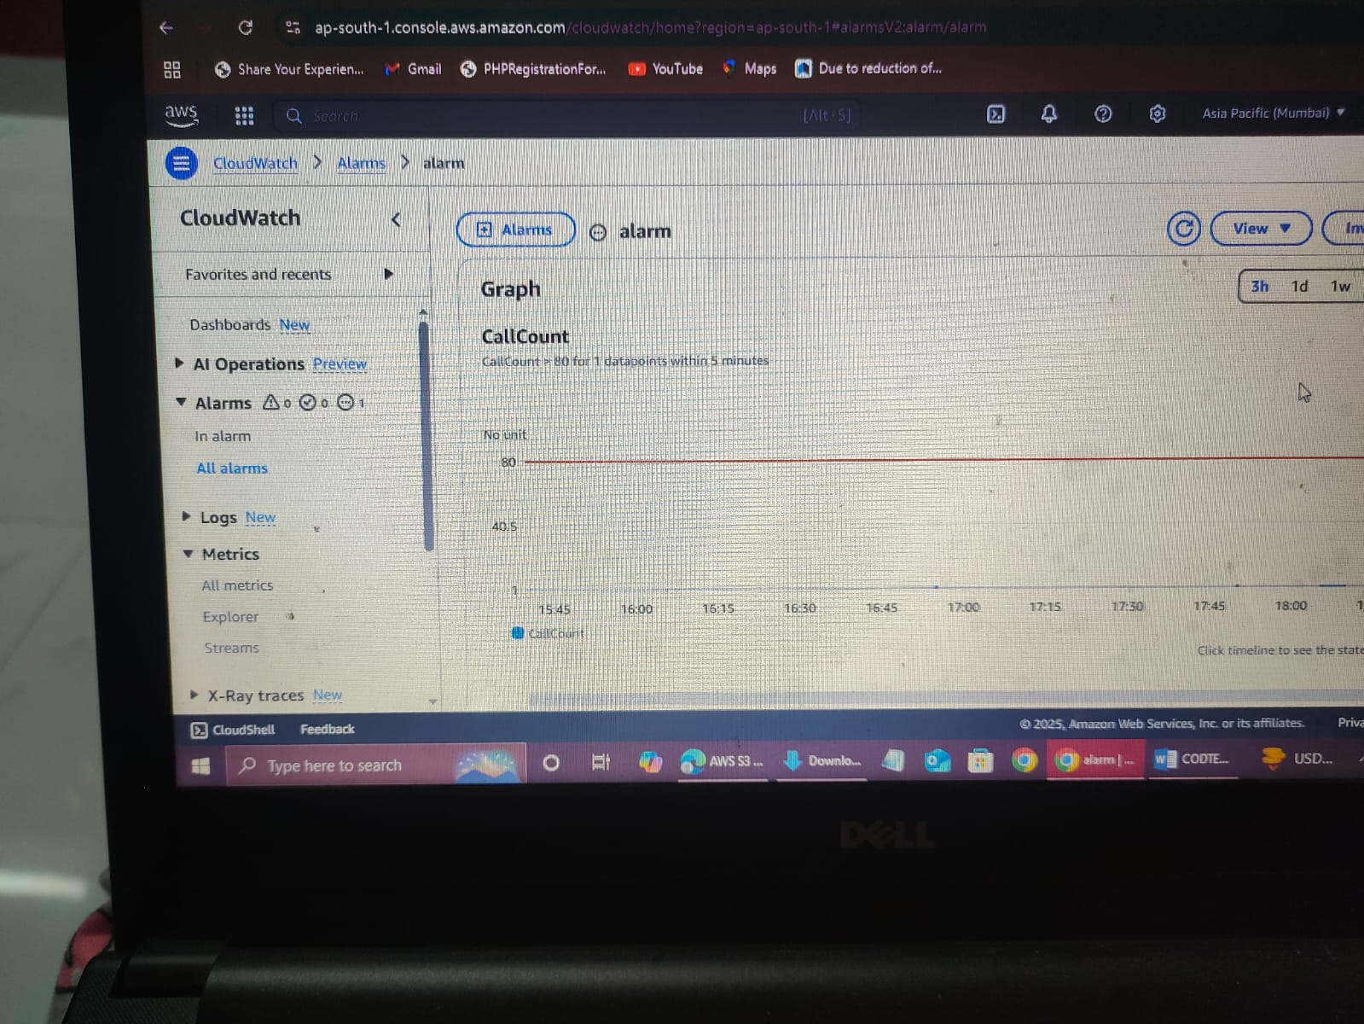

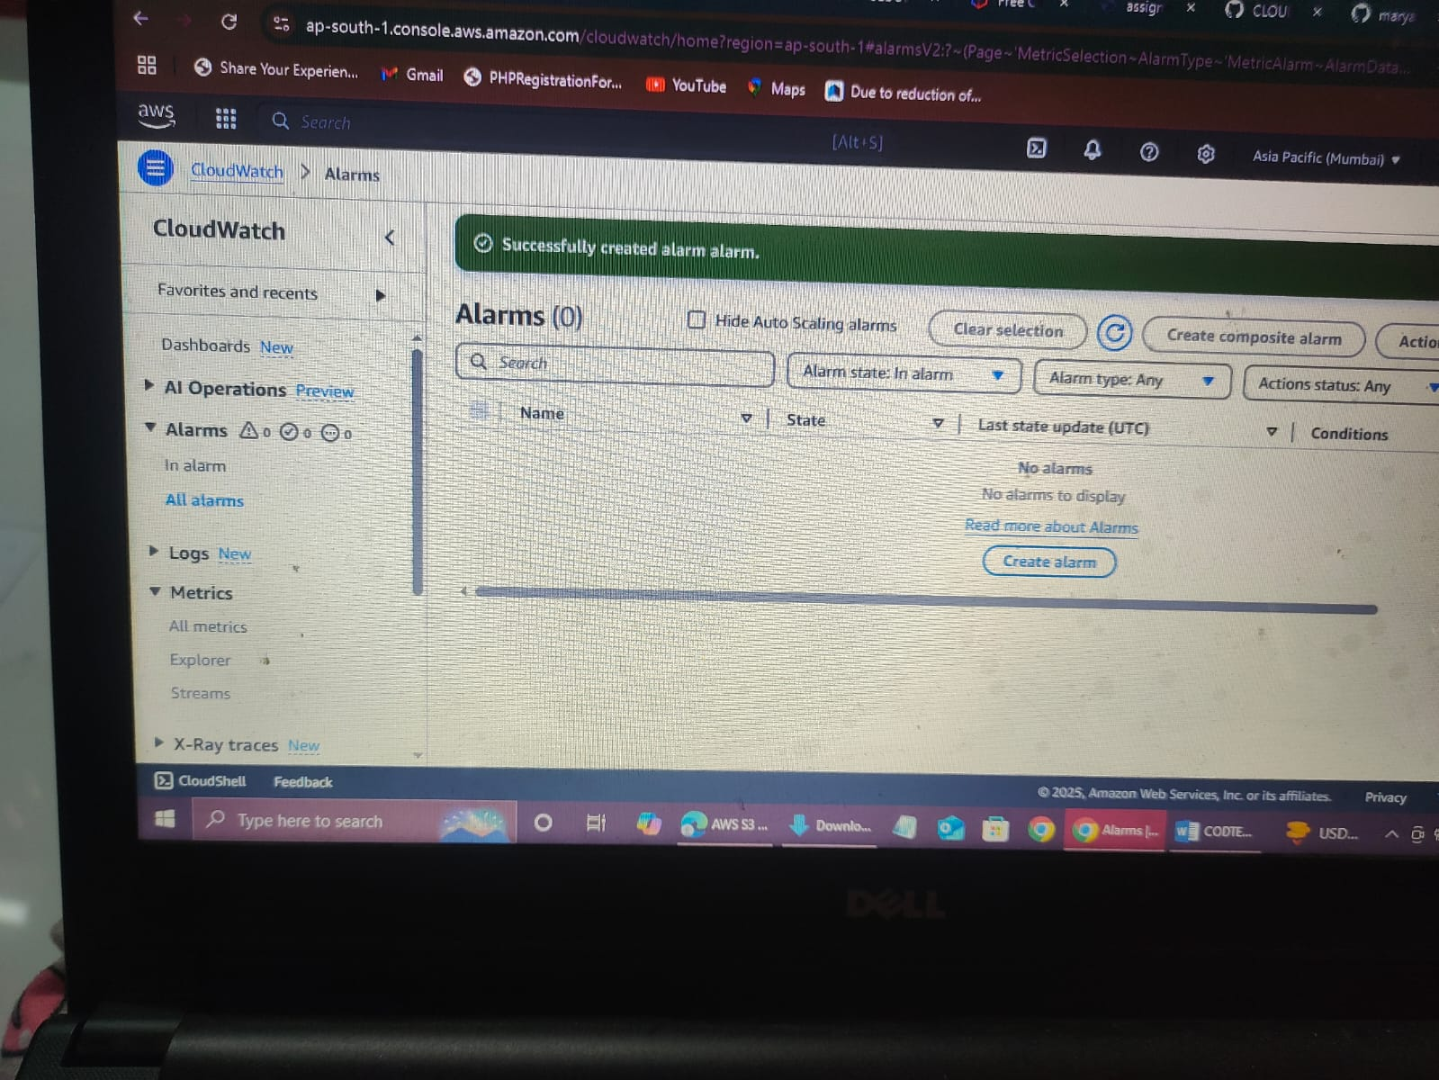

**THANK YOU!**